CMP SCI 4500
SG3 – Group 2
Tyler Bell
Cynthia Brown
Zack Hill
Ethan Hillebrand
Amanda Hoosech

Design Document

Table of Contents
Pseudocode.…………………………………………………………………………………….…………………3
Data Flow Diagrams…………………………………………………………………………………….……….5
Static Call Graph…………………………………………………………………………………….……………6

Pseudocode
Revision History:
- 11/20/2025 – Began SG3 design and pseudocode layout; identified GUI options and structure. (I use the SG2 design)
- 11/22/2025 – Outlined file handling, concordance logic, and extra list framework for GUI integration.
- 11/25/2025 – Added search and error-handling features; tested pseudocode logic consistency.
- 11/28/2025 – Revised and commented pseudocode for readability, GUI event flow.
- 12/01/2025 – Completed
Pseudocode:
BEGIN PROGRAM

DISPLAY splash window describing SG3 Concordance GUI functions.
// Initialize main window and interface options for user navigation

INITIALIZE main menu with options:
(1) Open Text File
(2) Find Word in All Files
(3) Build Concordance
(4) Close File
(5) Quit Program
// GUI buttons or dropdown selection menu replaces console prompts

INITIALIZE empty list OPEN_FILES to hold file contents.
// Stores all loaded and validated text data from user

WHILE program is running
WAIT for user menu selection.
// Loops until user selects Quit option

IF option = 1 THEN
PROMPT user to choose .txt file via dialog.
VALIDATE file extension and check duplicates.
IF valid THEN
READ file line by line.
CLEAN text (remove punctuation, fix hyphens, trim blanks, etc).
ADD file to OPEN_FILES and DISPLAY “File Loaded.”
ELSE DISPLAY “Invalid file.”
END IF
// Handles file input and validation through GUI interaction

ELSE IF option = 2 THEN
IF OPEN_FILES empty THEN DISPLAY “No files loaded.”
ELSE
PROMPT for search word; CONVERT to lowercase.
FOR each file and line
IF word in line THEN RECORD file, line#, and snippet.
END FOR
DISPLAY matches in output box.
END IF
//search across all loaded files and outputs results to GUI textbox

ELSE IF option = 3 THEN
IF OPEN_FILES empty THEN DISPLAY “No files to process.”
ELSE PROMPT to select file.
FOR each line (numbered)
SPLIT into words; FOR each word
CONVERT to lowercase; ADD (line#, word#) to CONCORDANCE[word].
END FOR
END FOR
SORT words alphabetically and WRITE to “CONCORDANCE.TXT”.
DISPLAY summary message.
END IF
// builds concordance for selected file and saves formatted output

ELSE IF option = 4 THEN
IF OPEN_FILES not empty THEN
PROMPT to choose file; REMOVE from list; DISPLAY “File Closed.”
ELSE DISPLAY “No files to close.”
END IF
// Manages open file removal through selection dialog

ELSE IF option = 5 THEN
DISPLAY “Exiting Program.” CLOSE all files and TERMINATE loop.
// Safely exits GUI and ends program

END WHILE

END PROGRAM

Data Flow Diagrams

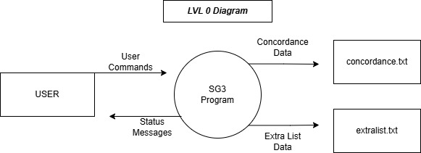

Static Call Graph
